Peer Review Checklist
QF-Test Test Case
AWIPS Software Maintenance & Support (SMS)
Version 1.0

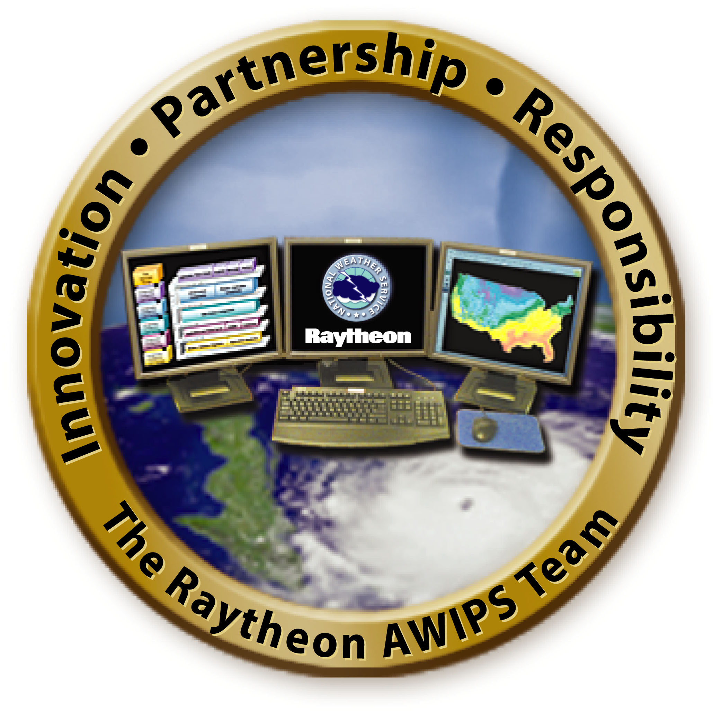

Prepared by:
Raytheon
Raytheon Technical Services Company LLC
8401 Colesville Road, Suite 800
Silver Spring, MD 20910

Last Updated:
June, 2012

This Document was developed specifically for the NWS / AWIPS Project. The concepts and methodologies contained herein are proprietary to Keane, Inc., a Teammate of the Raytheon Corporation for this engagement. Duplication, reproduction or disclosure of information is this document without the express written permission of Keane, Inc. is prohibited.

Revision History
This revision history is updated each time this document is updated. The history identifies the version number, the date the version was completed, the author of the changes, and a brief description of the changes.

Version | Date | revised BY | Description of Revision | Approver | SEPG IO #
1.0 | 6/19/2012 | Test Team | Original version

Project Name | AWIPSII | Received Date
Author | <Test Case Developer Name> | Complete Date
Review Type | <Desk Check / Formal Peer Review> | Review Date/Time
Product Type | <Baseline / Checkout Test Case> | Meeting Location
Product Name | <Test Case Title and Test Case ID from Test Case Template> | Number of Steps
Reviewer’s Name |  | Reviewer’s Phone
Release | <Release Number> | Prep / Review Time

No | Review Criteria | Yes | No | N/A
Launch cave dependency implemented?

Comments:
Is it internally consistent?

Comments:
Does it run?

Comments:
Does it satisfy the manual test case?

Comments:
Is it documented?

Comments:
Is the name appropriate?

Comments:
Is it commented properly?

Comments:
Are all the test steps error-free?

Comments?

